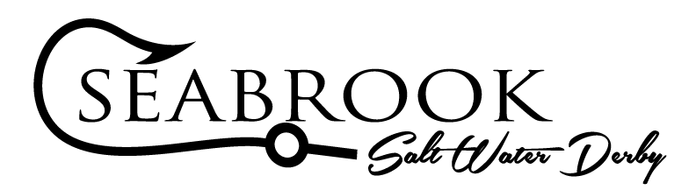

The 16th Annual Seabrook Saltwater Derby will be held at The Barge on Saturday, September 27, 2025. Advertising for the tournament is publicized in over 460 newspaper and print magazine publications and their affiliated websites and social media outlets statewide. In addition to these publications and postings, the Seabrook Saltwater Derby advertises via highway banner and billboard signage to attract entrants. This year we would like to extend sponsorship opportunities for you to advertise your business at the following sponsorships levels (See details below):

VIP ($5000) Diamond ($3000) Platinum ($2000) Gold ($1000)

If you would like to sponsor this event please complete and return the attached entry form with your donation by September 9th to a Seabrook Saltwater Derby representative, or mail to:
Seabrook Association
P.O. Box 1107
Seabrook, Texas 77586

The Seabrook Saltwater Derby is a Section 501(c)(3) charity event. Proceeds from this event will be used to support the Seabrook Association Scholarship Fund, provide equipment for special projects for Shriners Hospitals for Children, sponsor local youth sports and events for youth.

We appreciate your support, if you have any questions or would like to contact a committee member for more information about sponsorship we can be reached at:
Seabrooksaltwaterderby@hotmail.com

16th Annual Seabrook Saltwater Derby Sponsorship Levels

VIP Sponsorship ($5,000 Donation)
  - Friday Night Happy Hour Party (food, beer & cocktails provided) – a special thank you for your support.
  - Fully Guided fishing trip for up to 4 for the day of the tournament
  - Up to 4 Hotel rooms for the nights of 9/26/25 and 9/27/25
- Preferred beverages of choice in each room
- Reserved table at weigh in/auction
  - Sponsor Recognition Gift
  - Moisture wicking / Dri-Fit Seabrook Saltwater Derby shirts and hats for all fishing participants
  - SSWD Sponsorship Banner
  - 12 Drink Tickets @ weigh in/auction
  - Team (4 individuals) entry into tournament and entry into all side pots
  - Company Logo on…
    - Website
    - Facebook
    - Sponsor Banner (hung at Tournament)

Diamond Sponsorship ($3,000 Donation)
  - Friday Night Happy Hour Party (food, beer & cocktails provided) – a special thank you for your support.
  - Up to 2 Hotel rooms for the nights of 9/26/25 and 9/27/25
- Preferred beverages of choice in each room
- Reserved table at weigh in/auction
  - Sponsor Recognition Gift
  - Moisture wicking / Dri-Fit Seabrook Saltwater Derby shirts and hats for all fishing participants
  - SSWD Sponsorship Banner
  - 8 Drink Tickets @ weigh in/auction
  - Team (4 individuals) entry into tournament and entry into all side pots
  - Company Logo on…
    - Website
    - Facebook
    - Sponsor Banner (hung at Tournament)

Platinum Level Sponsorship ($2000 Donation)
- 2 VIP Night Hotel Stay for 9/26/25 and 9/27/25 – Can be either 1 room for 2 nights or 2 rooms for 1 night.

- Preferred beverages of choice in each room
- Reserved table at weigh in/auction
- Sponsor Recognition Gift
- Moisture wicking / Dri-Fit Seabrook Saltwater Derby shirts and hats for all fishing participants
- 4 Drink Tickets
- Team (4 individuals) entry into tournament
- Company Logo on…
  - Website
  - Facebook
  - Sponsor Banner (hung at Tournament)

Gold Level Sponsorship ($1000 Donation)

  - Sponsor Recognition Gift
  - Moisture wicking / Dri-Fit Seabrook Saltwater Derby shirts and hats for all fishing participants
  - 4 Drink Tickets
  - Team (4 individuals) entry into tournament
  - Company Logo on…
    - Website
    - Facebook
    - Sponsor Banner (hung at Tournament)


Business: Contact Name(s): Phone: Email:

If you would like to sponsor this event please complete and return this form and your donation by September 9th to a Seabrook Saltwater Derby representative, or mail to:
Seabrook Association
P.O. Box 1107
Seabrook, Texas 77586
*Make checks payable to Seabrook Saltwater Derby
Banner logos can be submitted@ Seabrooksaltwaterderby@hotmail.com

Please Complete Box:
(Circle Your Sponsorship Level Below):
VIP ($5,000) Diamond ($3000) Platinum ($2000) Gold ($1000)
Team Name:
Team Member Names & Shirt Sizes: 1.
2.

3.

4.

